# **HOW NOMZ WORKS**

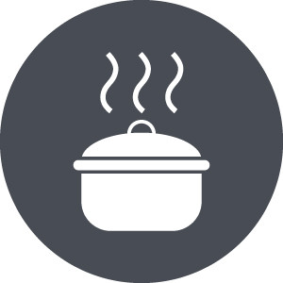

## WE STEW



## YOU CHOOSE



## WE DELIVER

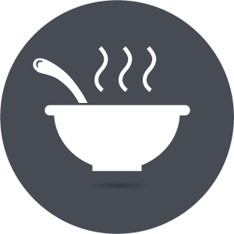

## YOU EAT (ANYTIME!)

## WE STEW

Our team prepares authentic Asian recipes – no General Tso’s here! – using high-quality ingredients, no MSG or added preservatives and strict processing standards. Our benchmarks are the delicious Asian noodle soups our parents made us growing up, and we aspire to stay loyal to the taste, standards and care our parents devoted to the craft. After hours of reduction, we place our broths in BPA-free containers custom-engineered for chilling and ultimately delivery.

## YOU CHOOSE

Select which traditional recipe you wish to purchase and add extras (such as noodles!) as necessary.

## WE DELIVER

You select the delivery date, we deliver nomz to door - all the work is on us! Easy! Currently, we deliver Tuesday and Sunday evenings, subject to change.

## YOU EAT (ANYTIME!)

Store nomz in your freezer and have a delicious and healthy meal ready in ~8 minutes of low-touch preparation whenever you desire.

# **HOW TO PREPARE NOMZ**



## PLACE

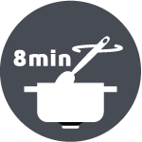

## HEAT

## SEASON

## PLACE

Place contents in pot (to remove, run water over container) + add 1 cup water (line on container is 1 cup).

## HEAT

Heat for 8 min or until contents have separated. Stir occasionally, keep covered.

## SEASON

Season with white/red pepper as desired. Serve with freshly cooked noodles (optional). Enjoy! (mandatory)